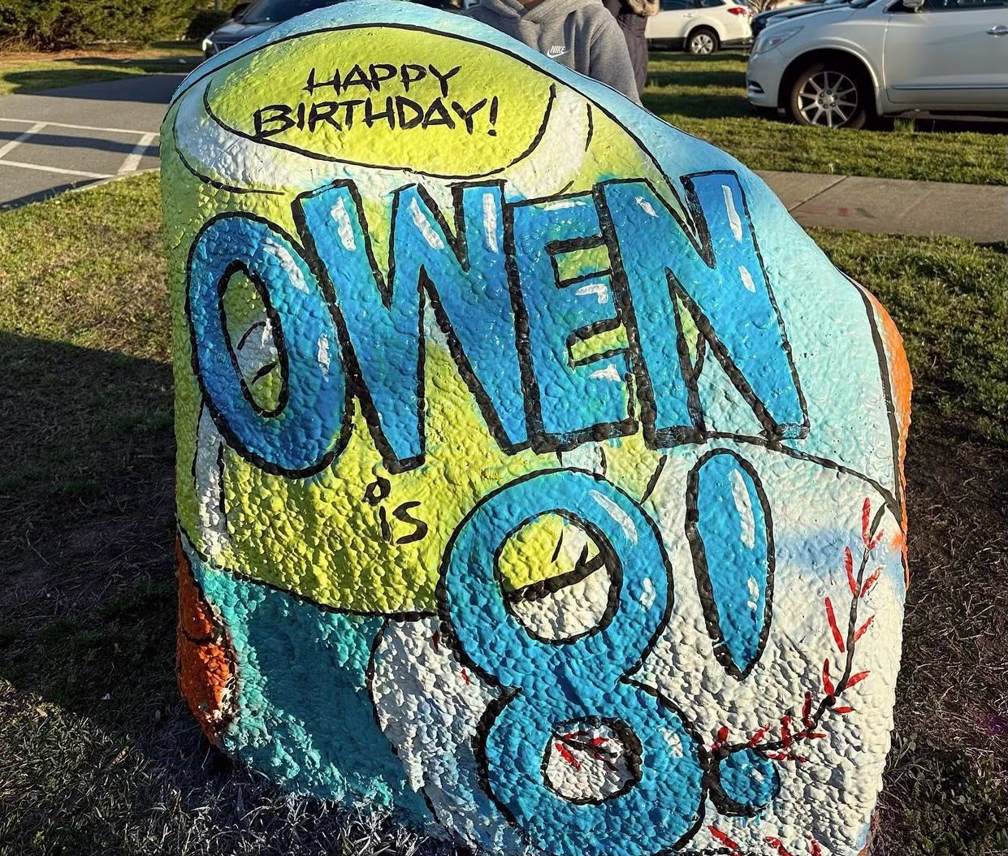

For only $15 you can reserve a day to paint the Saint Joseph Spirit Rock!

Reserve your spot today!
Our Spirit Rock is available for families, staff, teams, or clubs to reserve and show their school spirit! You can reserve the rock for your child/grandchild's birthday, to recognize your favorite teacher or staff member, congratulatory events, good luck on competitions and tournaments, or recognizing milestones.

The Spirit Rock is available for $15/day, all reservations will be billed through your school FACTs account. Reservations are made through our Sign-Up Genius. Sign-ups are for 24 hour periods from 5pm the day before until 5pm the day you reserved it. For example if you sign up for Thursday, September 15th you may paint the rock after 5pm on Wednesday, September 14th and will have it through 5pm on Thursday. Please triple check your dates! Saint Joseph School reserves the right to block dates for school use.

Sign up using the link below. Make sure to read all instructions carefully.
https://www.signupgenius.com/go/4090C48AAAE2DA3FC1-spirit

Spirit Rock Rules & Guidelines

1. Families must provide their own labor, paint , and supplies. Wear old clothes! See below for more helpful painting tips. Only the rock may be painted. Please take care to not damage the surrounding area, and pick up all trash after painting and dispose of it at home. An adult must be present during the painting.

2. The painting should be positive and reflect our Catholic values. No profane words, symbols, or any derogatory, offensive, or political messages will be permitted on the Spirit Rock.
St. Joseph reserves the right to remove any content from the Spirit Rock that is deemed inappropriate.

3. The family painting the rock assumes liability for any individual or member of the group who may be injured, or for any clothing or personal property that is damaged.

4. No refunds will be issued in the case of bad weather. If wet, the rock can be towel dried before painting, spray paint will adhere even in rain or snow. We will try to accommodate you with another date in the event that you absolutely cannot paint the rock on your designated day.

5. The Spirit Rock runs on the honor code, with the expectation that everyone will respect these guidelines. All money raised from the use of the Spirit Rock will go towards supporting the school!

Spirit Rock Painting and Design Tips
- The best paint to use is spray paint. Premium spray paint works best (Rustoleum, etc) vs. a generic store brand. You will probably need 2-3 cans for a good base coat and additional paint for your design. The quantity needed will depend upon the color you are using, the color already painted on the rock, and weather conditions. Remember, latex paint or paint that is rolled on will take longer to dry.
- Once you have the base coat done, use chalk to sketch out your design. Try to do large shapes so that it’s easy to see from the road and so that you can use spray paint for most of it.
- Stand back from the rock to make sure you can see the design from there.
- Spray paint your large areas. If you mess up, use your base coat color to fix the mistake.
- For more detailed areas, use a can/tube of paint and a paintbrush. While outdoor latex is best, regular artists' acrylic seems to work well too (even in rain).
- Make sure to bring paper towels to wipe any drips
- Bring a cup of water if you are using a paintbrush.
- Wearing rubber gloves will help keep your hands clean.
- Have fun and post photos to our Facebook page!

